

**Submitted by : Spogmai Jan**

**Roll No : 2430 - 0081**

**Submitted to :Sir Bilal Dar**

**Subject : Programming Fundamental Lab**

Lab Task 08

Task 01 : **Day of the Week**

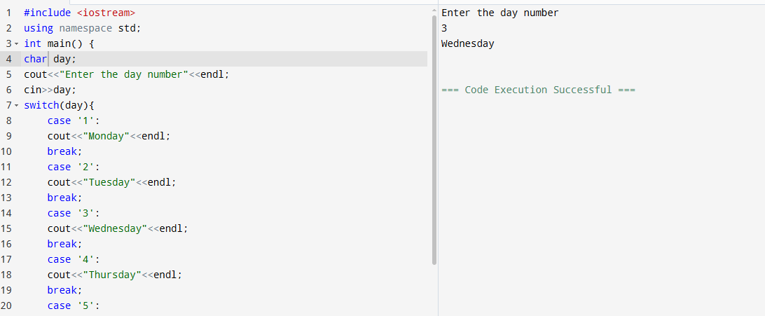

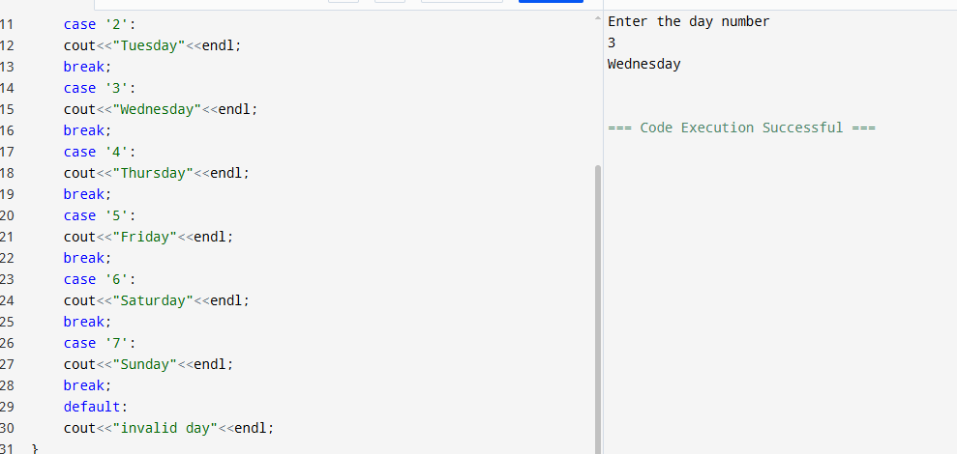

**Task 2: Simple Calculator**

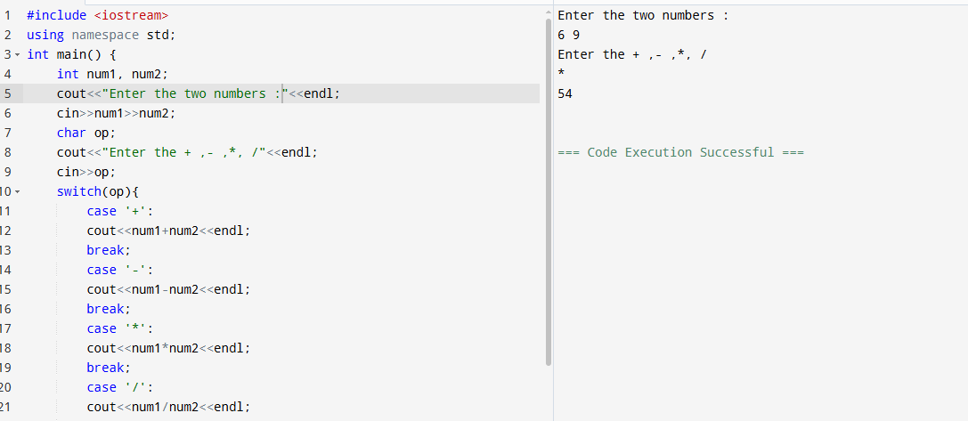

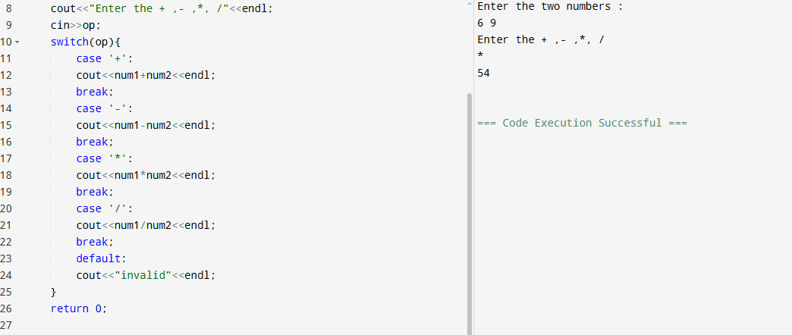

**Task 3: Vowel or Consonant**

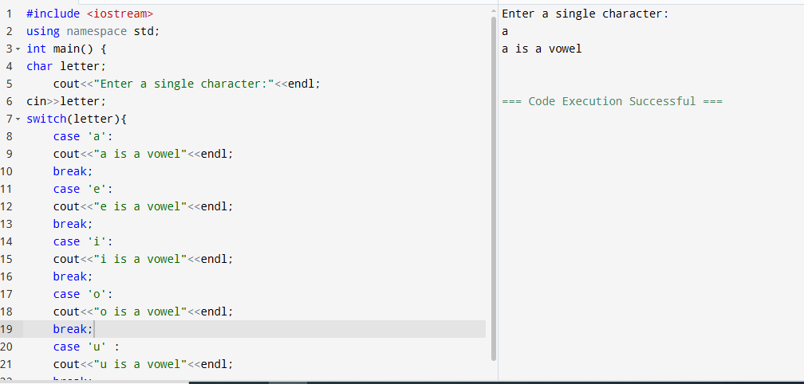

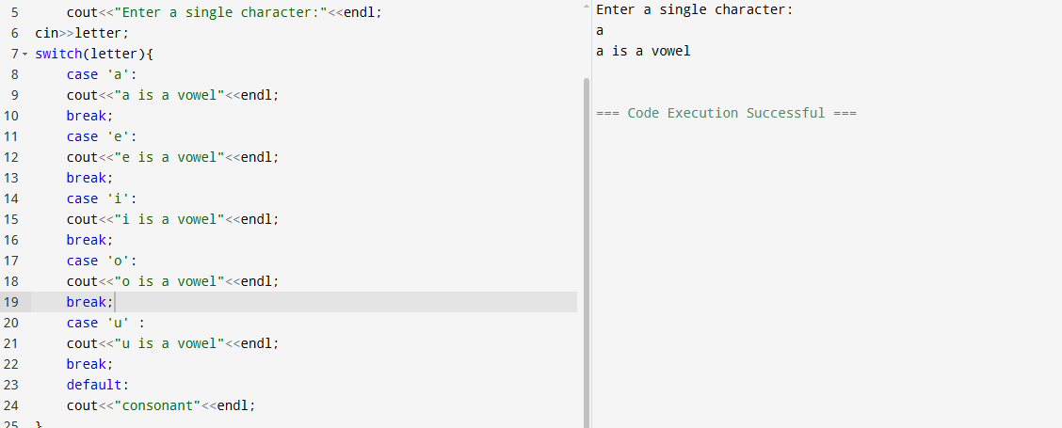

**Task 4: Grade Converter**

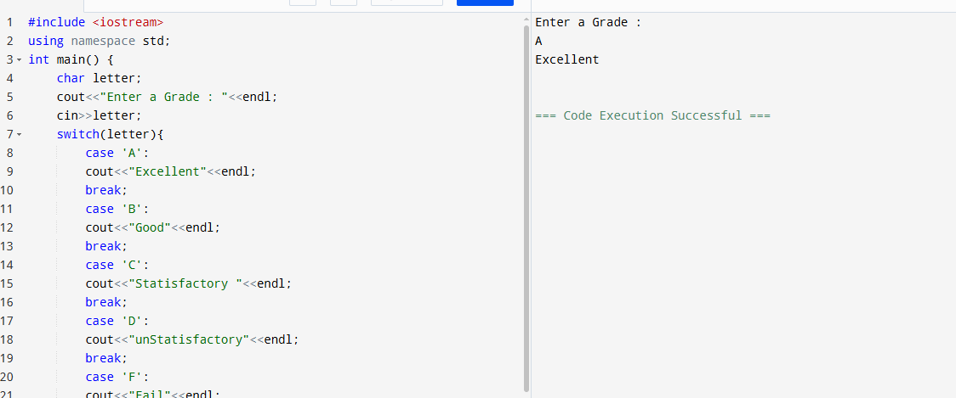

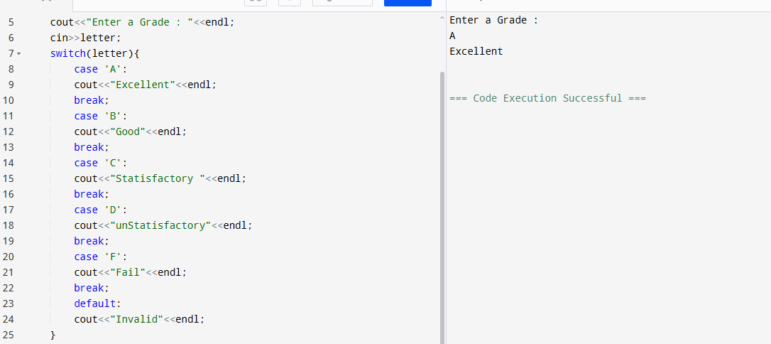

#### **Task 5: Simple Bank Transaction System**

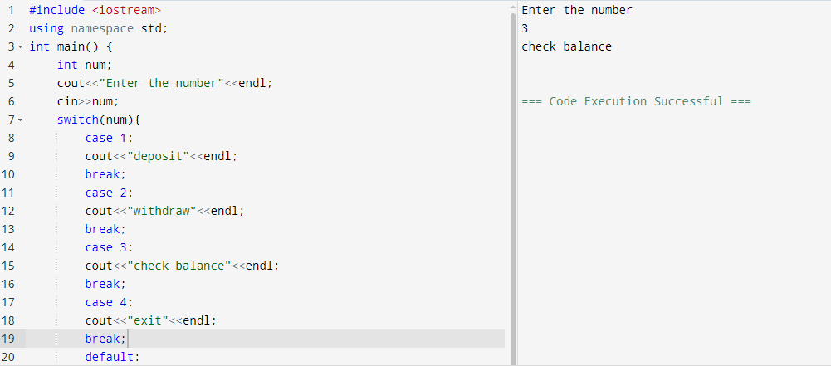

#### **Task 6: Simple Traffic Light Simulation**

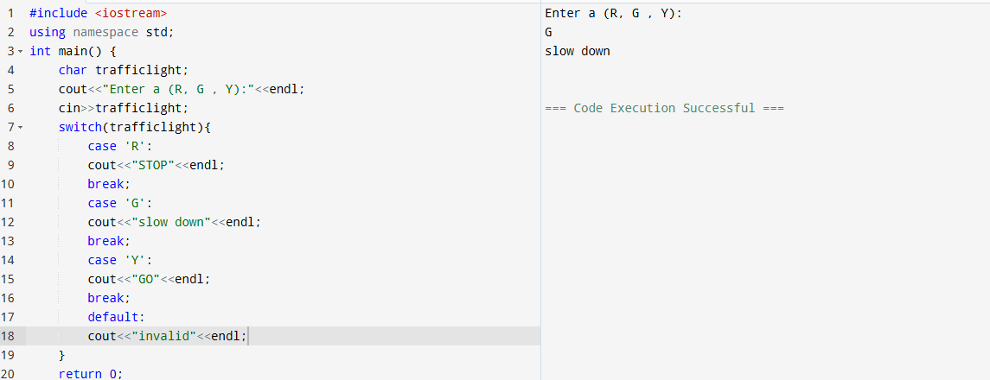

**Task 7: Representing months**

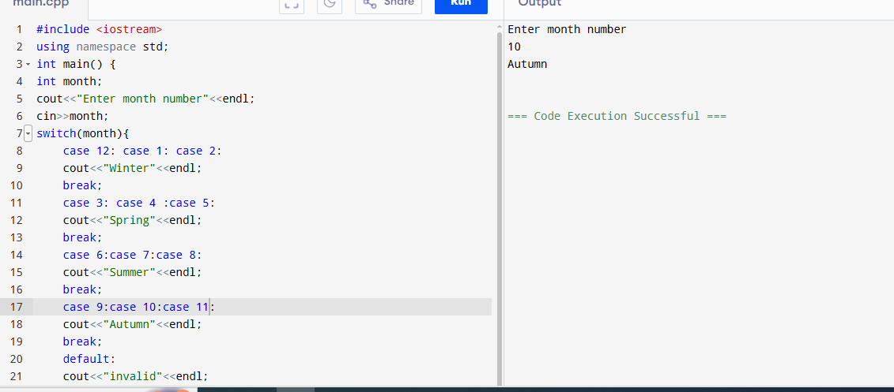

**Task 8: Number to Words**

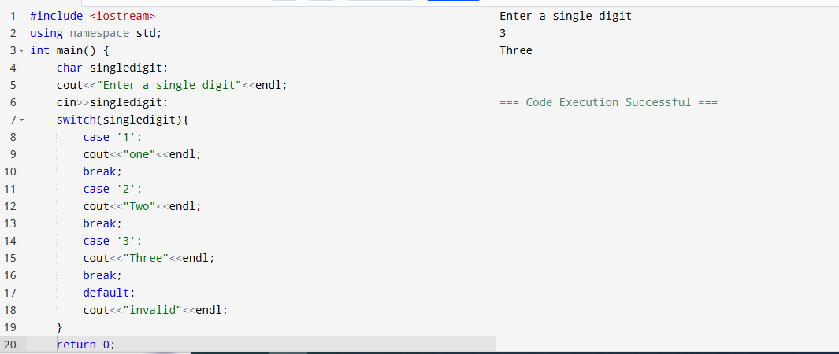

----- THE END -----